**World Quant University**

**Professor: Tiberiu Stoica**

**Machine Learning**

Nikolas Lippmann Pareschi - [nikolaslippmann@gmail.com](mailto:nikolaslippmann@gmail.com)

**Unit 4 Project**

### Overview

You are given the following data set, which consists of latitudes, and longtitudes of locations of people who are predominantly  Python, Java, or R users.

The first part is to hard code the latitudes and longitudes provided byt the wqu machine learning classes:

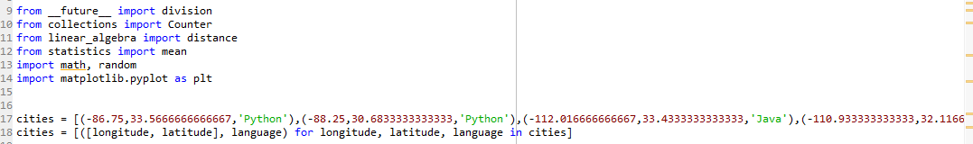

One should notice that we use other py files, like statistics and linear_algebra, please execute those files before executing the main Mini Project 4 file. After that we need to create a knn classifier

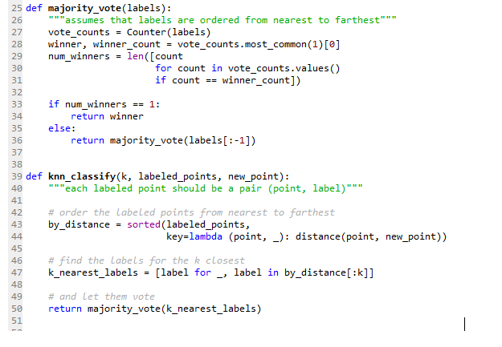

Then we proceed with the classification for k of 1, 3 ,5 and 7 as requested:

Final results:

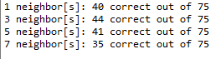

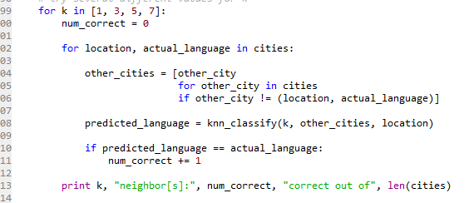

For this Mini Project I used the excellent book: Data Science from Scratch by Joel Grus